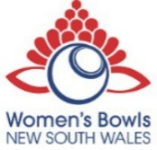
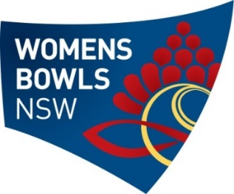
APPLICATION FOR OFFICIAL REPRESENTATION

Please complete the form below and return to Women’s Bowls NSW to request the attendance of a State Representative at a Club Birthday (25th, 30th, 40th & 50th & then in 10-year intervals) or Presidents’ Day or District Birthday’s (in 10-year intervals starting from 30 years)

Club Name: |  |  |  |  | District:
Type of Event/Function: |  | Presidents Day |  | Women’s Club Birthday
 |  | Combined President’s Day and Women’s Club Birthday
Details – e.g. 50th
Day and Date(s) of Event:
Host Venue:
Arrival Time of Guest:
(State Representation will not arrive before 10am)
Expected finishing time:
Last WBNSW Official Visit:
Host President’s Name: |  |  |  |  |  | Phone:
Host Secretary’s Name: |  |  |  |  |  | Phone:
Host Secretary’s Email:
Type of game (if applicable) – e.g. Triples, Fours:
Location of event – please provide full street address and directions to assist in locating venue and parking.
Any other relevant details:
Signed: |  |  |  |  | Club Secretary Club President

**Please note: A President can only present four merit pins during her three-year term. This can include a President day or Birthday or combined President’s Day & Birthday. The presentation of this award is the highest honour the Association can bestow. The Club President can select up to 4 members whom she feels worthy of a Merit Pin for their years of service to the club. Recipients are selected by Club President only without the assistance of anyone else. The names of the recipient should be given to the Women’s Bowls NSW Representative, on the day of the event by the Club President, with a short citation of the recipient’s service to the club. Merit Pins cannot be awarded by Districts.

You will be invoiced the $50 fee on approval of this application.

